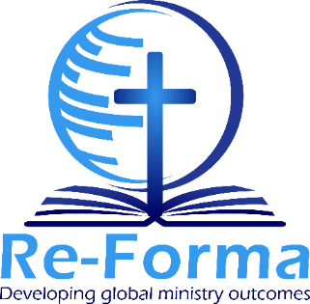

Assessment Sheet

This sheet must be filled out for each student by the teacher, pastor or facilitator who taught the Re-Forma outcomes.

NOTE TO FACILITATOR: In order to maintain the standard required for the student to earn the Re-Forma Certificate, underwritten by the World Evangelical Alliance, it is very important that you only tick YES to each question below, if you are absolutely sure that the student has fulfilled the requirements.

Name of Student
Student’s Email
Name of your Church/Organisation
Your Name
Your Email

 | YES | NO
- Did the student attend at least 70% of the classes?
- Did he/she hand in everything you required?
- By the end of the program, did the student successfully demonstrate all the outcomes? Can he/she now do what the outcomes require?
- God being your witness, are you satisfied that the student has passed this program?

Signed: Date:

Once the student has successfully demonstrated ALL the outcomes, please email his/her assessment sheet, with all the others in the group, to vicky@re-forma.global

